 | B.M.S. COLLEGE OF ENGINEERING, BANGALORE-19  Computer Science & Engineering
INTERNALS-III
Course Code: 23CS4PCADA |  | Course Title: Analysis and Design of Algorithms
Semester: 4 |  | Maximum Marks: 40 | Date: 18-06-2026
Faculty Handling the Course: |  | Dr.KSS, PA, MS, Dr.JSN, Dr.BSR, Dr.NM, Dr.HSG, Dr.ST, AAS, DK, MNM, RP, HSM
Instructions: Internal choice provided in Part C.
Scheme of evaluation
PART-A
Total 5 Marks (No Choice)
No. | Question | Marks | CO-PO
1 | Prove that Boolean satisfiable problem reduces to clique decision problem.Let the boolean expression be F = (x₁ v x₂) ^ (x₁' v x₂') ^ (x₁ v x₃).where x₁, x₂, x₃ are the variables, '^' denotes logical 'and', 'v' denotes logical 'or' and x' denotes the complement of x.  Solution:  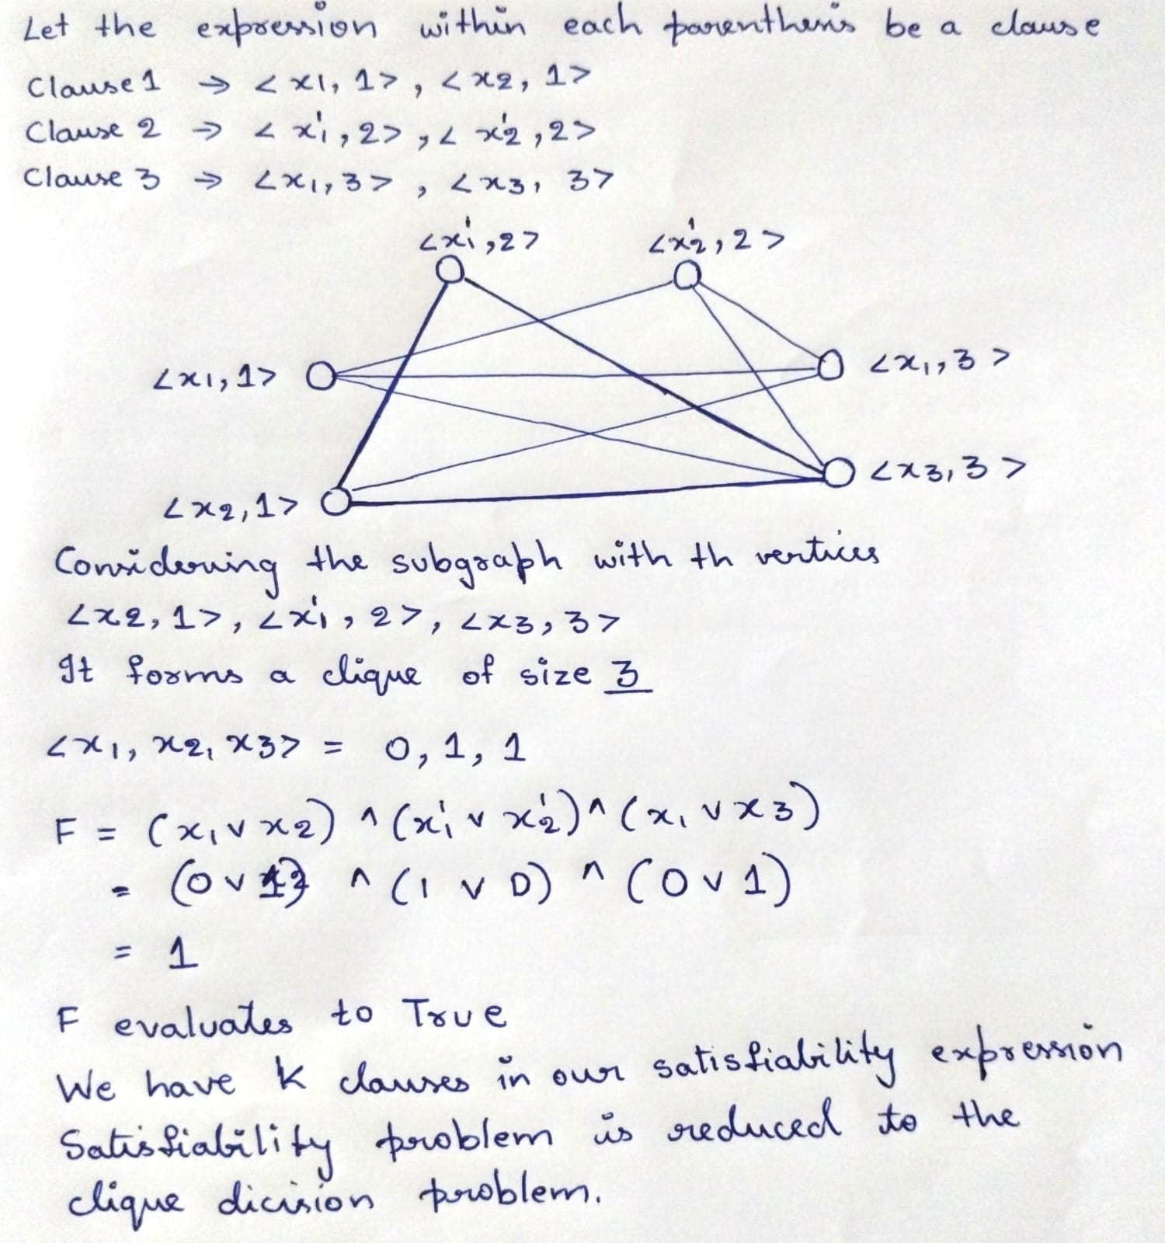 | 5 | 3-1
PART-B
Total 15 Marks (No Choice)

No. | Question | Marks | CO-PO
2 a) | A defense agency is setting up a surveillance network on a square monitoring grid. different radar systems—Sentinel Radar Sensor, Falcon Radar Sensor, Guardian Radar Sensor, and Titan Radar Sensor—must be deployed on the grid.  - Identify the suitable algorithmic technique. (1M)  - Place sensors on the grid such that no two sensors can be placed horizontally, vertically or diagonally with all intermediate steps (4 M)  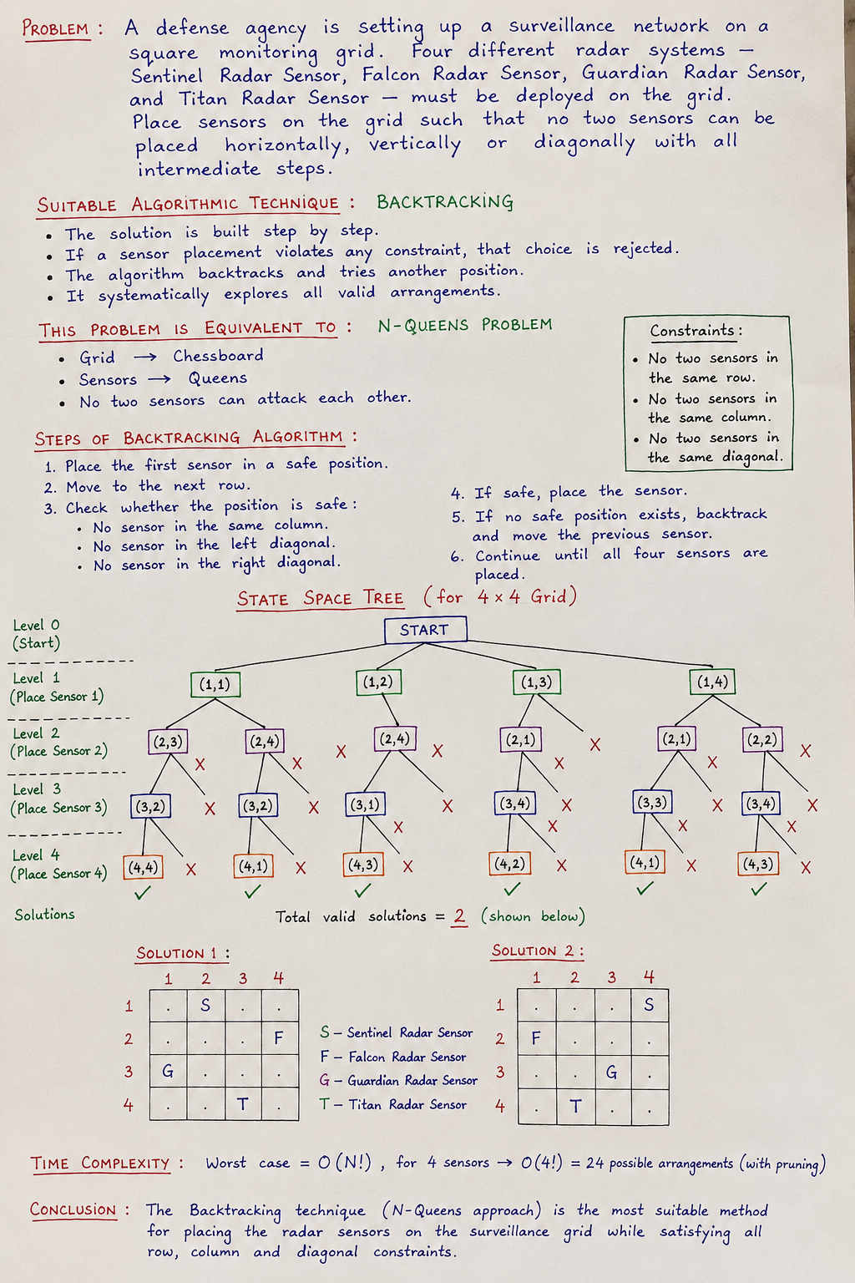  Solution:  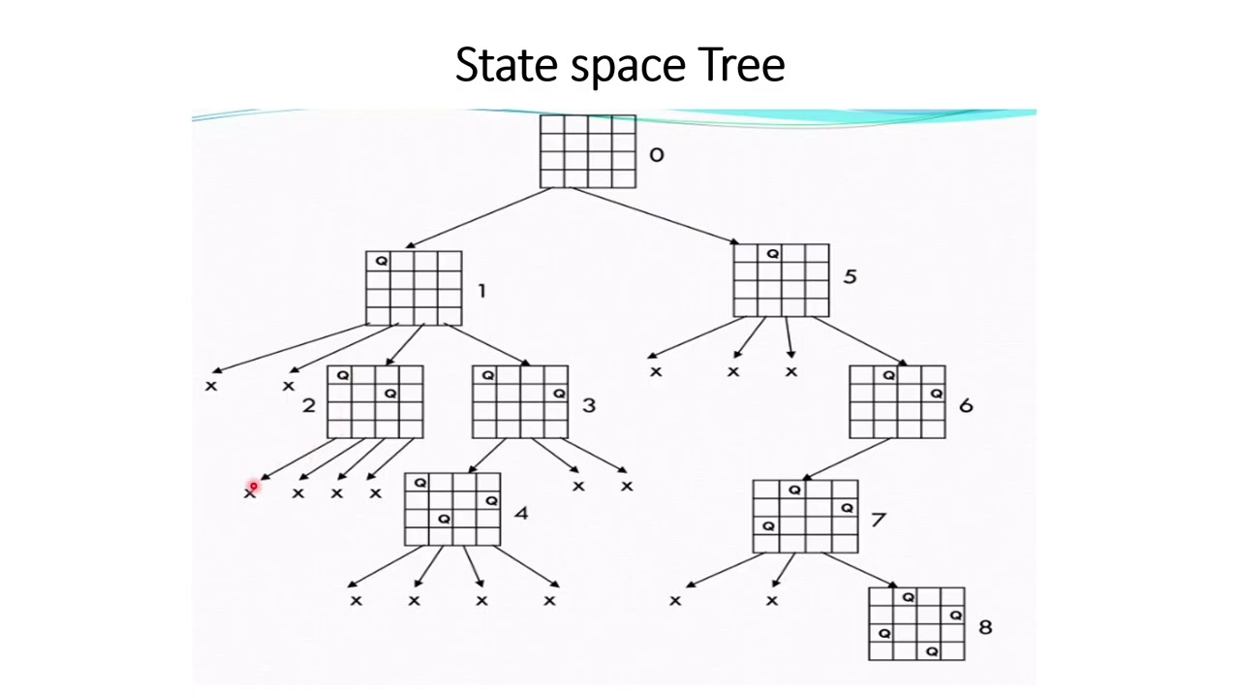 | 5 | 2-1
2 b) | A finance company is preparing an investment portfolio using available investment plans worth ₹10 lakh, ₹12 lakh, ₹13 lakh, and ₹15 lakh. The company wishes to invest exactly ₹25 lakh.find all investment portfolios which constitute a budget of ₹25 lakh. Draw the corresponding state-space tree.  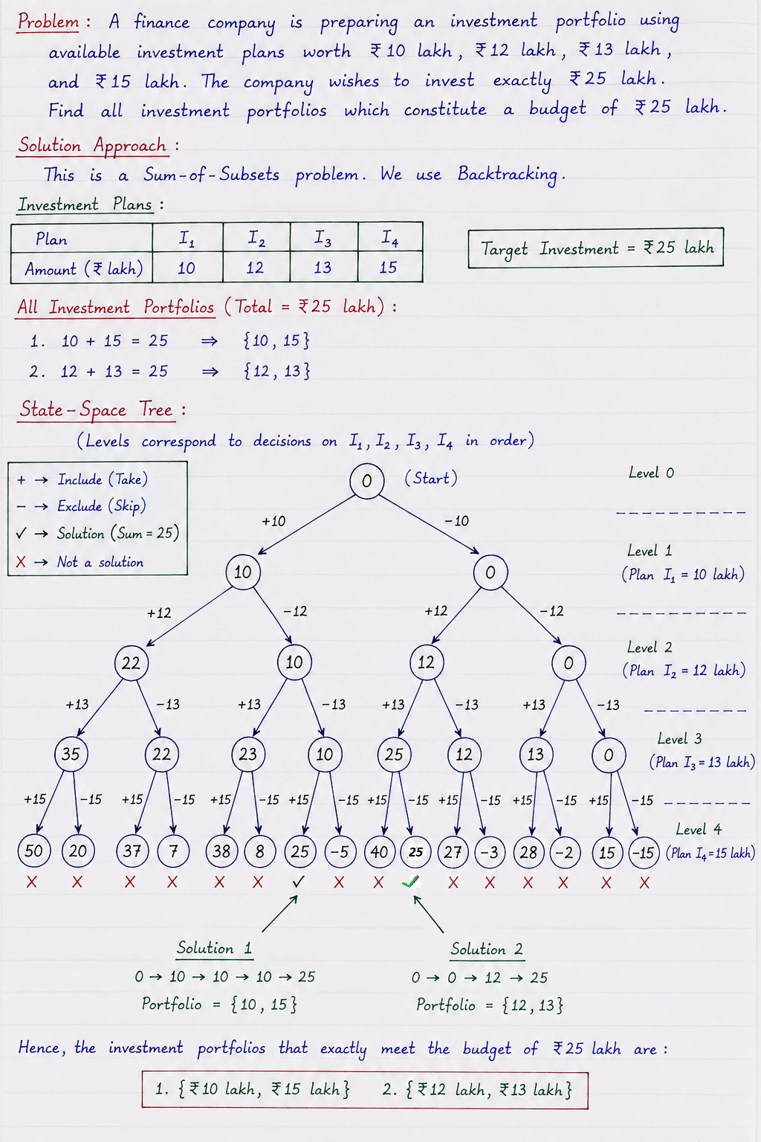  Identification - 1M  State space tree -4M | 5 | 2-1
2 c) | A digital forensics team is searching for a suspicious keyword within a large communication log.  Text (T): NETWORKSECURITYNETWORK  Pattern (P): WORK  (i) Construct the shift table for the pattern. (1 M)  (ii) Apply Horspool’s algorithm to locate the pattern in the text.(2 M)  (iii) Determine time complexity and compare it with bruteforce. (2 M)  Construct the Shift Table  In Horspool's algorithm, the shift value for each character is:  where i is the position of the character in the pattern (excluding the last character).  Pattern: W O R K  Shift Table  Character Shift  W 3  O 2  R 1  K 4  Others 4  ii)Apply Horspool's Algorithm  Step 1  Align pattern with first four characters:  T: N E T W O R K ...  P: W O R K  Compare last character:  · T[3] = W  · P[3] = K  Mismatch.  Shift = value of W = 3  Move pattern 3 positions right.  Step 2  Pattern starts at index 3:  T: N E T W O R K S ...  W O R K  Compare from right to left:  Pattern Text Result  K K Match  R R Match  O O Match  W W Match  All characters match.  Pattern found at index = 3  Therefore,WORK occurs in NETWORKSECURITYNETWORK starting at position 3 (0-based indexing)  iii)Time Complexity  Time complexity of Brute force O(mn) and Horspool is O(n). | 5 | 2-1

PART- C
Total 20 Marks

No. | Question | Marks | CO-PO
3 a) | A genomic research laboratory searches DNA sequences for a specific gene marker.  Text: ABCDABCABCABCDABCABCABCEABCABCE  Pattern: ABCEABCABCE  (i) Construct the bad-character table and good suffix table and apply the suitable algorithm using tables constructed.  ii) Compare the improvement in the performance by including a good suffix table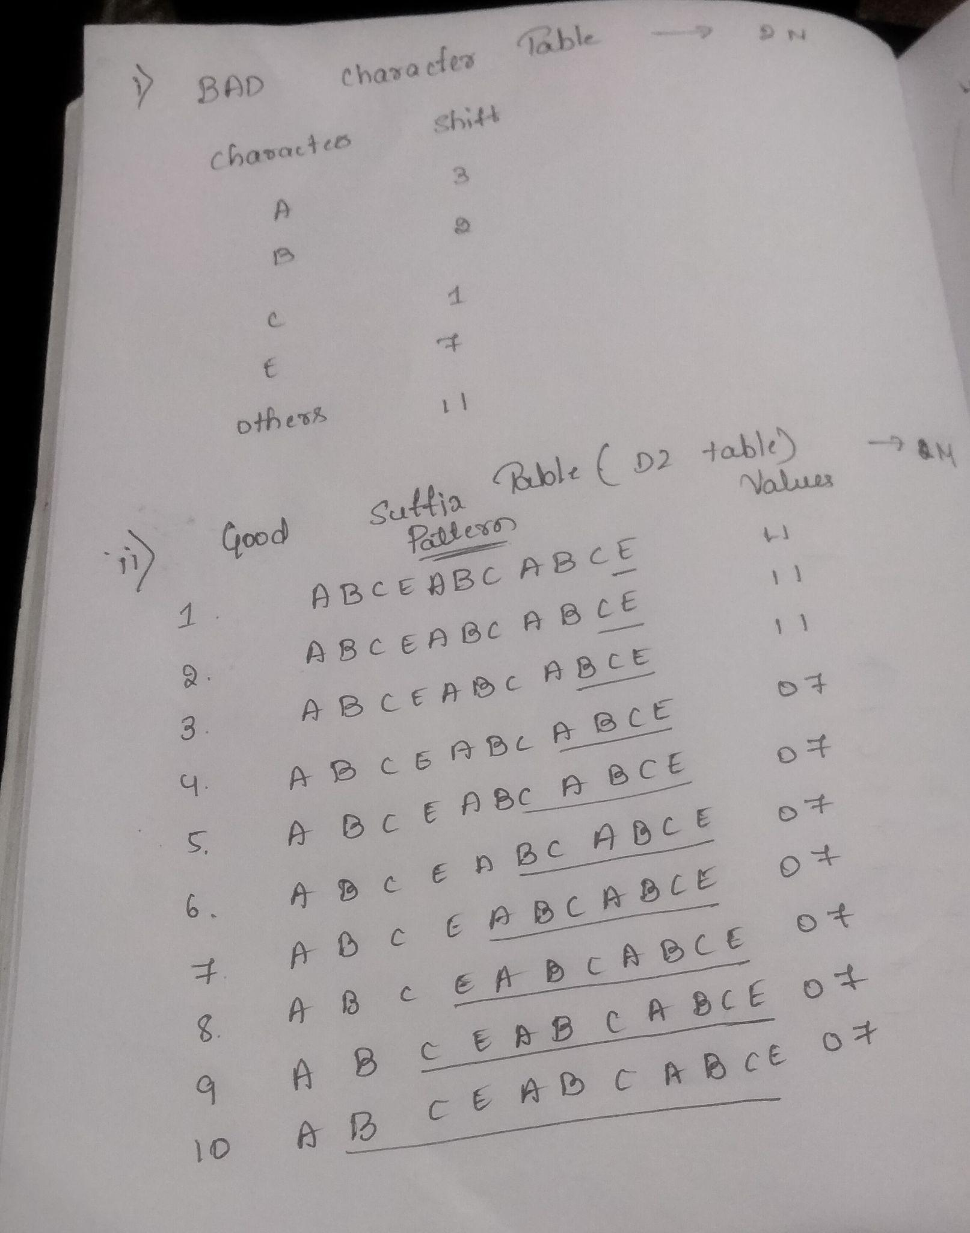  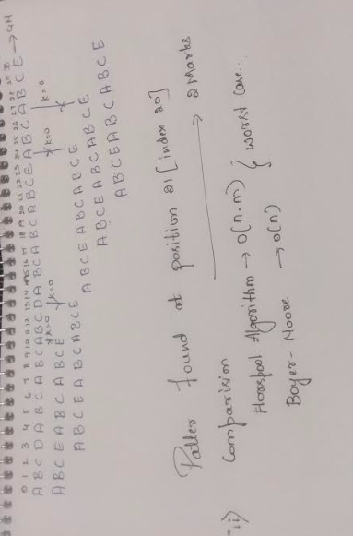 | 10 | 2-1
 | OR
3 b) | A cargo airline must maximize revenue while loading cargo within a weight limit of 15 tons.  Cargo Weight Profit  C1 2 40  C2 5 30  C3 10 50  C4 5 10  C5 8 35  i)Construct the state-space tree. 4M  ii)Compute bounds at each node.4M  iii)Identify promising and non-promising nodes.1M  iv)Determine the optimal cargo selection and maximum profit.1M  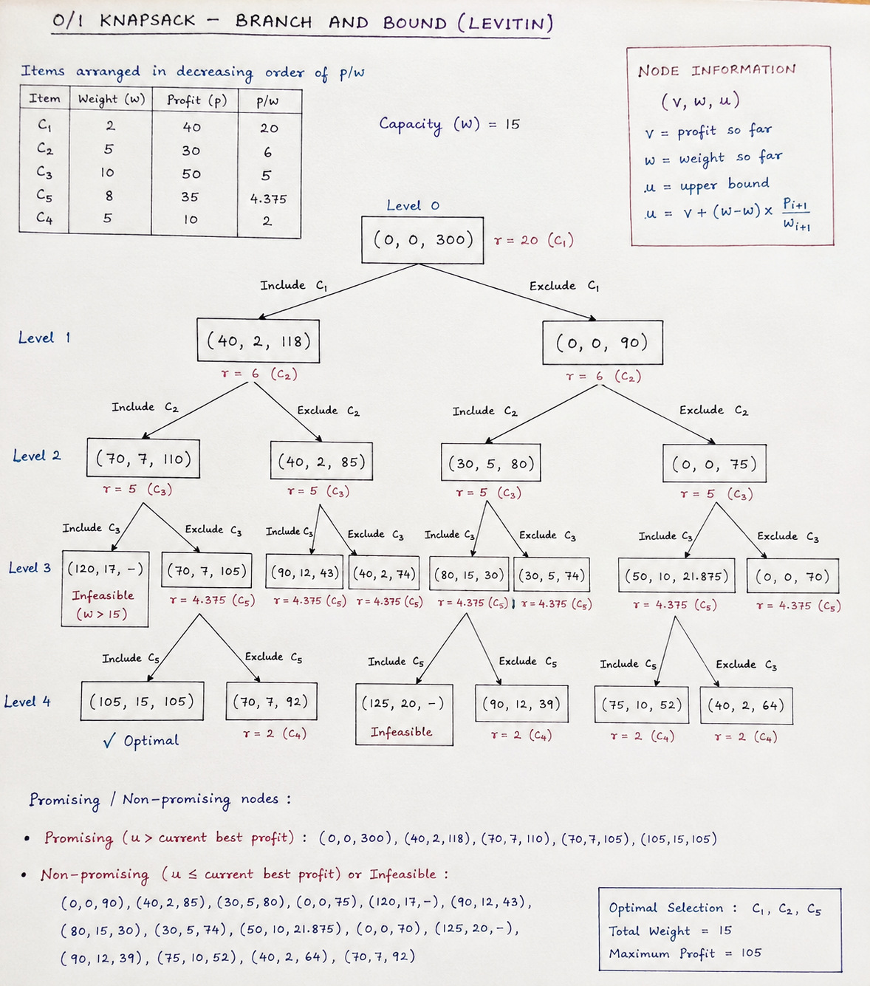  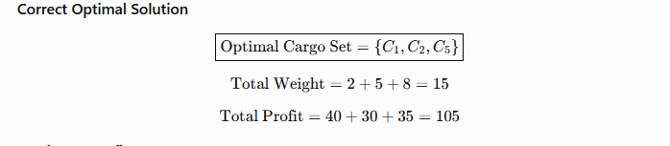 | 10 | 1,2-2,1
4a) | a) A network administrator wants to install monitoring devices at selected routers in a communication network so that every communication link is connected to at least one monitored router. The network is represented by the graph V = {A, B, C, D, E, F} and E = {(A,B), (A,C), (B,D), (C,D), (D,E), (E,F)}. Identify the graph problem represented by this scenario, determine a minimum set of routers on which the monitoring devices should be installed, verify that every communication link is covered by at least one monitored router.  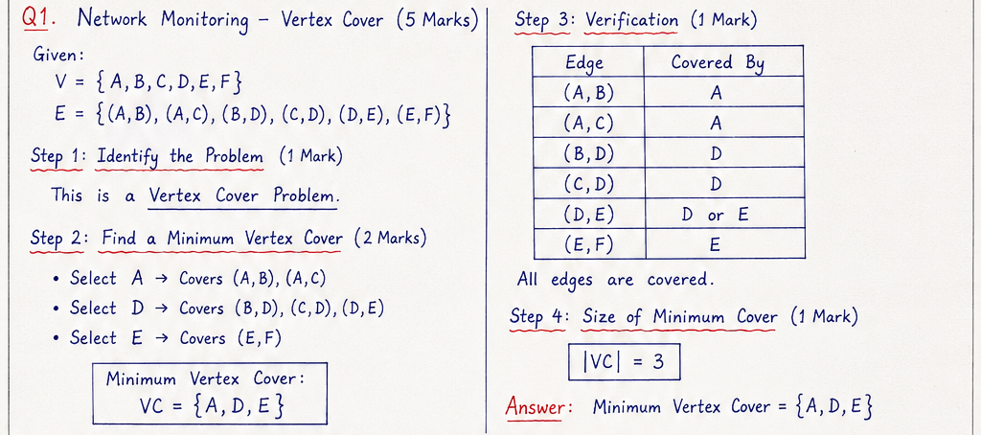  b) A smart home has multiple security requirements. For each security condition, at least one of three sensors must be active.The house is equipped with movement detection using Motion Sensor OR Door Sensor OR Window Sensor,Unauthorized access detection using Camera OR Alarm OR Motion Sensor,Intruder detection using Glass Break Sensor OR Camera OR Door Sensor Each sensor may be active or inactive .Identify the combination of sensors which will ensure security for the home.  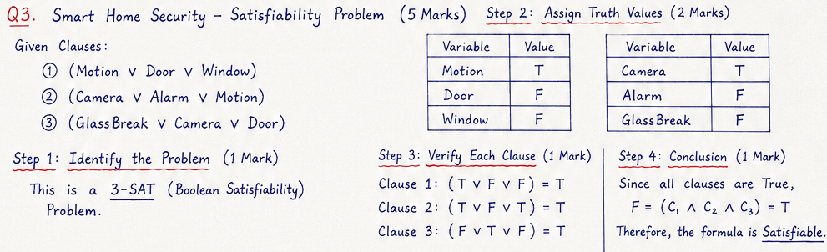 | 10 | 2-1
 | OR
4b) | A courier company must deliver parcels from warehouses to five cities while minimizing fuel cost. Given the cost matrix:  A B C D E  A - 14 4 10 20  B 14 - 7 8 7  C 4 5 - 7 16  D 11 7 9 - 2  E 18 7 17 4 -  - Determine the optimal tour by computing the lower bounds for branching nodes starting from city ‘A’. (8M)  - Calculate the minimum travel cost.(2M)  Solution:  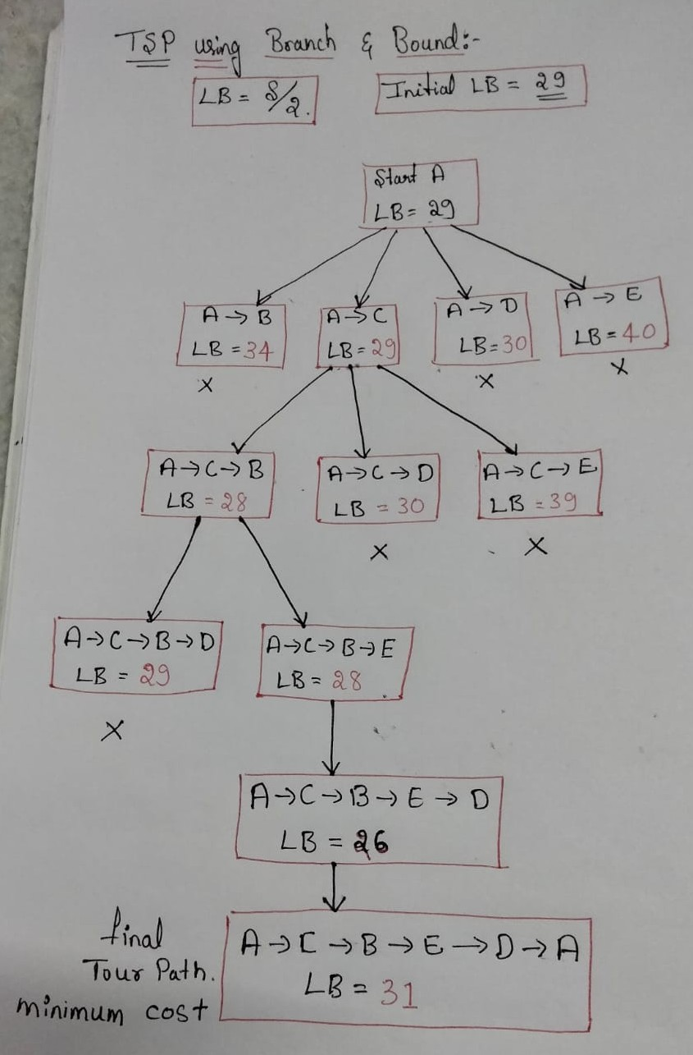  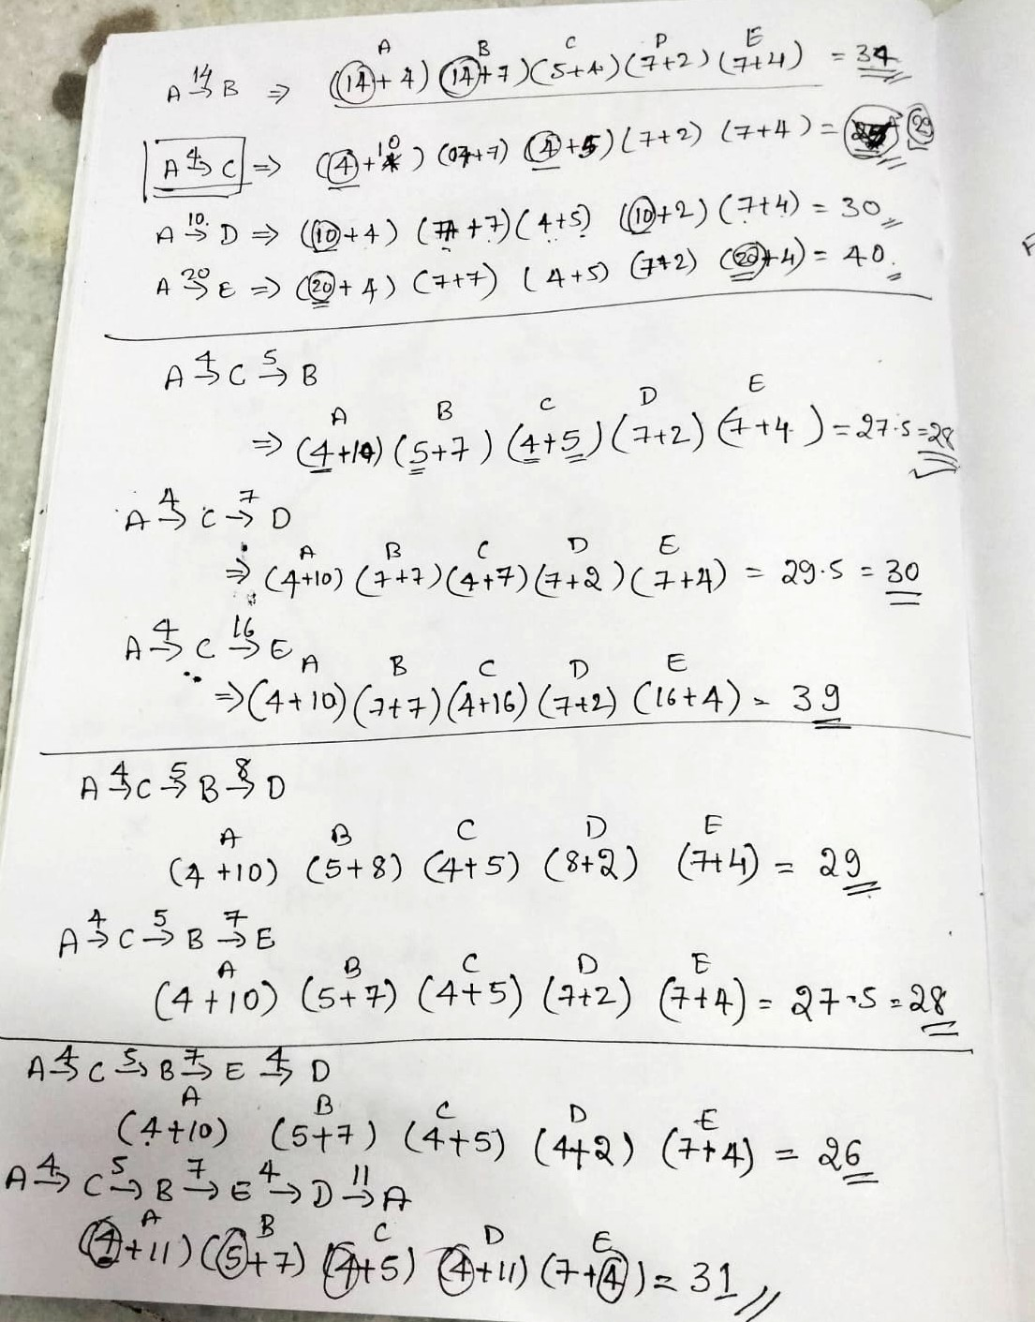 | 10 | 2-1

***ALL THE BEST***

